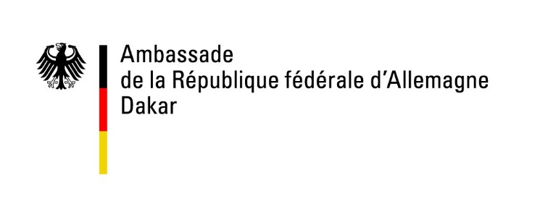
Information Leaflet on Micro-Projects
I. General Information
The German Embassy in Dakar finances several small-scale projects every year to improve the living-conditions in the rural and urban areas in The Gambia. These micro-projects are aimed at providing a punctual aid responding to the basic needs of the poorest population.

By the means of a micro-project, the Embassy can for example provide real assets or contribute to the construction of a building or infrastructure. However, the municipalities or associations requesting financial aid have to be able to provide a self- contribution to their projects. This contribution can consist, for instance, in providing manpower, building materials, transportation or water supply, depending on the project's nature.

The Embassy wants to point out that together with the need to assure financial self-contribution, no salaries within the demanding organisation will be paid by the Embassy.

Some examples:

- Drilling of a small well for a village community / installation of an irrigation system for a vegetable garden of a women's association / fencing of a vegetable garden
- Provision of a milling machine, a water pump, a copying machine etc.
- Acquisition of gardening materials, tables and benches for schools, etc.

The Embassy will reject applications

- which will only benefit small groups (like individuals or families).
- that have a religious, cultural, political or military character.
- that are presented by unorganized associations.

The Embassy is not able to grant micro-credits.

II. Formalities

Please present the following documents to the Embassy / the German liaison office of the Gambia in Kololi:

- the application-form demanding financial-aid for a small-scale project together with the detailed finance plan

- a detailed description of the project (who will benefit from it, how long will it take to accomplish the project, who will ensure the long-term success?)

- a map of the project area displaying the project location

- two pro-forma invoices for all materials and services needed – these pro-forma invoices must match with the positions mentioned in the finance plan

- a detailed description of your group including proof of your official registration

- a declaration of non-profit objectives of your group or association

- a declaration that neither you nor your association have been granted financial-aid for this project by any other (German or non-German) institution

- a declaration that the project has not started yet

- the written approval of the local authorities concerning the project

The funding amount varies from approx. 7.000 Euro to approx. 10.000 Euro.

It is indispensable that the submitted projects can be realised / implemented within 6 months after signing the contract.
III. Proceedings

Please hand in your application to the German liason office of the Gambia in Kololi (1 Paradise Beach Place, Bertil Harding Highway, P.O.Box 833, Kololi/The Gambia).

Due to the high number of projects presented, the Embassy asks for your understanding that a personal interview is not always possible. Should the Embassy require further information, it will directly contact the spokesperson of the project.

After studying the presented projects, a committee will decide which projects to support.

The Embassy wants to point out that its resources for supporting small-scale projects are limited. Unfortunately, a large number of projects will have to consequently be refused.

Please note: A refusal does not judge the quality of your project-idea.
In case the German Embassy agrees to finance your project, please find below some further information.

IV. Management of funds, responsibility
As the project's spokesperson you are responsible for buying the required materials according to the presented pro-forma invoices and for submitting the originals of the receipts and invoices to the Embassy.

The receipts and invoices have to include:
- name and place of the project (or number of the project given by the Embassy)
- name of the project's spokesperson
- date, name, signature, address and seal of the salesman
- annotation that the invoice has truthfully been paid

In case of presenting invoices for employees:
- name of the beneficiary including a contract
- number of working hours
- name of the project's spokesperson
- spokesperson's signature and seal
- treasurer's signature and seal

At the end of the project you have to present a detailed written report to the Embassy. We will hand over the corresponding form when signing the contract.
Your team of the German Liaison Office Gambia
Revised: November 2020

